|  |  |
| --- | --- |
| Key Vocabulary | |
| mammal | A mammal is a warm-blooded creature that gives birth to live babies. A mammal has fur or hair. |
| amphibian | An amphibian is a cold-blooded creature. Amphibians can breathe in and out of water. |
| insect | An insect is a creature whose body is split into three sections called the head, the thorax and the abdomen. |
| metamorphosis | An abrupt change in the structure of the animal’s boday and their behaviour. |
| bird | A bird is a vertebrate. It has a beak, feathers and wings, although not all birds can fly. |
| reproduction | The process of new living things being made. |
| life-cycle | The journey of changes that take place throughout the life of a living thing including birth, growing up and reproduction. |
| sexual reproduction | Two parents are needed to make offspring. |
| asexual reproduction | One parent is needed to create an offspring. |
| fertilise  (fertilisation) | The action of fusing the male and female sex cells in order to develop an egg. |
| puberty | The physical stage of development between childhood and adulthood. |
| menstruate  (menstruation) | When the female body discharges the lining of the uterus (a period). |

|  |
| --- |
| Y5/6  Where do Things Come From? |
| In Science this term, the children will learn about the life cycles of living things. They will investigate the development of babies and compare the gestation period of humans and other animals. They will learn about the changes experienced during puberty and why these occur. |

|  |
| --- |
| Background Knowledge |
| Children will already know that and be able to:   * recognise living things and the life processes they need to stay alive. * sort and group living things according to their characteristics and behaviours. * classify vertebrates and invertebrates. * name the 5 groups of vertebrates (mammal, bird, fish, reptile and amphibian) and give examples for each group. * use classification keys * be familiar with life cycles as they have studied it through plants. |

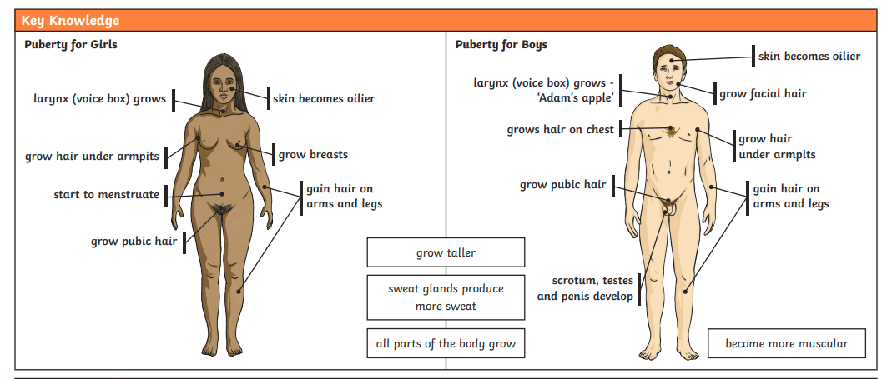

|  |
| --- |
| Key Facts |
| 1. If an egg is not fertilised, there is no embryo and so no chick will develop. We can eat the egg. |
| 1. Amphibians metamorphose as they start life in the water and change into an adult that lives on land (and in water). |
| 1. Kangaroos are marsupials- which are different to other mammals because they have a pouch where they keep their babies after they are born. |
| 1. In asexual reproduction the offspring will be a clone (exact copy) of the parent so desired features are always passed on. |
| 1. In sexual reproduction the offspring will look a mix of the two parents. This diversity amongst the species means disease doesn’t affect all. |
| 1. The Pituitary gland and Hypothalamus are the parts of the brain that make more hormones to make puberty happen. |
| 1. Puberty takes place over a few years and happens so that reproduction can take place during adulthood. Boys’ bodies start changing from around age 12 but it can be earlier or later. Girls’ bodies start changing from around the age of nine but it can be earlier or later. |